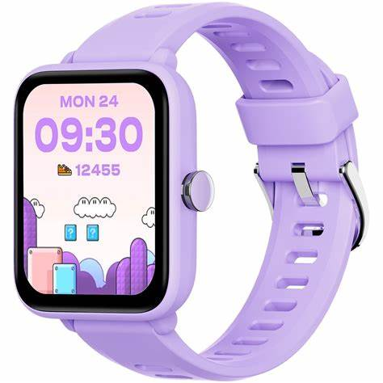**Description**: **BIGGERFIVE** is a brand known for its high-quality fitness trackers and smartwatches designed primarily for children and teenagers. Their products focus on encouraging an active lifestyle by offering features such as step tracking, heart rate monitoring, sleep tracking, and calorie counting.

BIGGERFIVE fitness trackers typically feature a lightweight, comfortable design with adjustable straps suitable for smaller wrists. Many models include waterproof capabilities, long battery life, and compatibility with smartphone apps for progress tracking. These watches help parents and kids monitor physical activity while promoting healthy habits in a fun and engaging way.